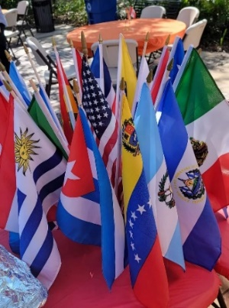
For Immediate Release Oct 12th, 2023 Info: Jolie Gonzalez-Padilla Info: Jolie@HRFCC.org or (813) 407-6866

Hispanic Heritage Celebration in YBOR City @5th Annual Ford Taste of Latino Festival. #connectford
Ybor City’s Centennial Pk on Sun, Oct 15th

Tampa, FL; Celebrate Hispanic Heritage in Ybor City/Tampa, Florida on Sunday, Oct 15th, 2023, at Centennial Park: 1800 E. 8th Avenue, Tampa, FL. Free General Entry. Time: Noon – 6 PM.

The 5th Ford Annual Taste of Latino Festival is BACK at Centennial Park in Historic Ybor City!
The free family festival will be held on 3 City Streets, as well as at Ybor’s popular Centennial Park. The VIP area will be held at the Ybor City Museum and Gardens. Guests will enjoy Food, ART and LIVE Music! BRING your beach chair and ENJOY LIVE Performances by! PLUS Vaya DJ, Johnnie Rivera and our emcee dance pro Chris Maloof. Guests can also enjoy Free Salsa Dance Lessons!

Are you a good Domino player? If so Register to be a part of our Domino Tournament! - Registration starts at 12Noon at 19th Street Pavilion. ENJOY the Awards Ceremony Featuring the 2023 TOP Latino Lideres (Latino Leaders) with Leaders coming from all over Tampa Bay and Florida to be recognized and receive the Latino Lideres Award and the Amigo “El Amigo” Award on Stage.

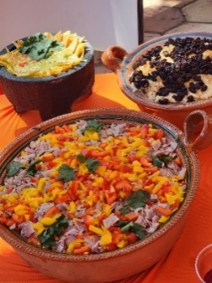
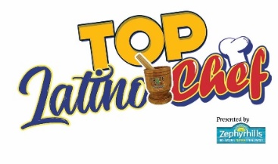
Awardees Include: Luis Capdevilla, Anthony & Allison Fonseca, Miriam Valkenburg, Nancy Millán, Cristy Balderrama, Kyandra Valle, Fox New’s Regina Gonzalez, Honorable Judge Miriam Valkenburg, Roberto Leon, Julia Palacios, Kandy Windom, Roberto Borrero, Maura Cruz-Lanz, Lisette Bonano, Edwin El Calvito Reyes, Rosario Torres, Lisa Pages, Cary Seaholm, Danielle Hernandez, Anthony Gonzalez, Joe Lopez from Naiddi Flan, Nicole Quinones-Diaz, Vanessa Cahuas Jasmin Gracia, Jaime Yepes, plus Ann Marie Bizarretty Cash, our Amigo awards: Jennifer Mallan from Come Home with Jen and Chef Gaston Merideth.

Top Latino Chef Contest, presented by Zephyrhills Water: Latino Dish Contest Features Top Chef Latino Dish -Professional contest to see who makes the BEST Latino Dishes in Tampa Bay! Contestants include: Empanadas, Paella and MORE!

This is also the first year where we will be giving out CASH PRIZES for the TOP WINNERS in all 4 Categories – PLUS in addition to receiving the CASH prize of $1,000 for First Prize, and $750, $500, and $500 for subsequent winners – but our presenting sponsor of the Top Latino Chef Contest – Zephyrhills Water will be donating out an additional $1,000 Check in the name of each of the winners -to the winners choice of non-profits!

Sponsors Recognized at the Event: FORD Motor Company; HRFCC, VISIT TAMPA BAY, Zephyrhills Water, CENTRO TAMPA, Maxima 925FM, Florida Blue, VIZA Law, ESTRELLA TV, MORE TV, La Teresita Restaurant; Latin Times Magazine; Vaya DJ.

Hashtags: #ConnectFord #HispanicHeritageMonth #YborCity #TASTEOFLATINO #Empanadas #CubanSandwich ######## More info at: www.TasteOfLatino.com

